Listen to me!

Where is Tom? Teacher: Catherine Date: 19 August 2010
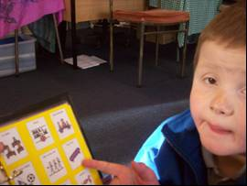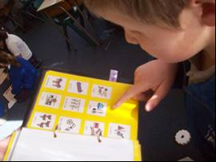
It was morning time. Tom and Sue went to his Where is Tom? board and Tom picked out the Milo visual. Sue stood at the doorway and said, “Tom, show your teacher.” Tom walked over to me. I was working with a maths group sitting on a chair leaning over the group as we worked. Suddenly I felt a hit on the front of my shoulder. I looked up as Tom hit me the second time. I looked down and Tom had stuck the Milo visual on to my shoulder. He then turned around and walked off. The kids in the class laughed and went “Wow Tom!” Jack said, “His communication is so good.” Tom walked to Sue who was standing at the doorway.

How fabulous to see Tom using the strip in such a functional way. He clearly wanted to communicate his information and get to that Milo. How wonderful to observe a class community supporting and recognising Tom’s communication efforts.

Tom Teacher aide: Sue Date: 20 August 2010
It was Friday afternoon. The class was completing art work at their desks. I said to Tom, “Would you like to go for a walk?” I got the communication book and showed him the photos of where we could go down town. He made sounds that I interpreted as a very clear No and he shut the communication book. I offered him the closed communication book and asked him, “What do you want to do? “ Tom opened the book.
He went through the pages until he found the photo of his dad. He pointed to his dad. Then he flicked through to the back of the book and located the picture of the car in the garage at home. He pointed to the picture.
I said, “Oh darling it’s too early to go home. “Assembly first.” Tom went back to the front of the book and pointed to the photo of his mum. I gave him a big hug and said, “Oh darling I wish I could take you home.” I offered him the choice of a walk to town and he was happy with that.

How exciting to observe Tom searching the book to get the specific information he needed. I was impressed to see him go back and locate his mum’s photo too. Tom clearly was tired and wanted to go home, just like many others on a Friday afternoon!

Tom Teacher: Annie Date: 25 August 2010
The bell had gone and we were sitting on the mat to do the roll. Some of the class were missing as they were at music. We sat on the mat with the remaining class members and Tom’s communication book was in front of him. When the teacher said, “Good morning Tom” I placed my hand on Tom’s and we pointed together at the photo of Tom’s teacher.
The teacher talked to the class for a few moments. Tom was getting very grumpy and I could not understand why. I asked him, “Tom, what’s wrong?” He looked at the page of the communication book and pointed repeatedly at the photo of his teacher aide Sue. Sue and I had swapped times to support Tom and I interpreted Tom’s pointing to be a question , “Where is Sue.?” I pointed to my photo in the communication book and said, “Annie first, then Sue.” I pointed at Sue’s photo.
Tom appeared happy with this information and stopped making unsettled noises.

Although I am interpreting Tom’s question in relation to Sue I was so impressed to observe him using the book to ask a question or to make me aware that he was missing Sue and her daily routine of being with him. Great work Tom.

Tom Teacher: Annie Date: 25 August 2010
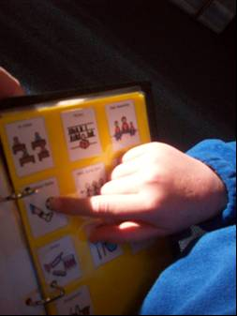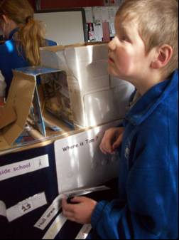
We were on the mat and the class were singing songs. Tom was getting very excited and started to jump up and down, waving his arms and legs around. He began to make loud noises. He became louder and louder and started kicking the floor. I interpreted these actions as Tom needing a break in the sensory room. I opened his communication book and said, “Tom, Let’s go sensory.” Tom looked at the page, took my hand and pointed a number of times at the music symbols. I pointed to sensory. Tom took my hand and pointed to Music. I waited. Tom pointed again at the music symbols. I said, “OK Tom. After music we will go sensory.” We stayed for all the songs. Then Tom and I walked to sensory together.

Well done Tom. You were able to use the book to state clearly what you wanted. Your pointing was specific. I believe your request was met because you stopped making unsettled noises and you were happy to go to sensory when the music finished.

Tom Teacher’s aide: Sue Date: 24 August 2010
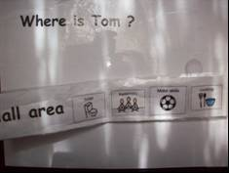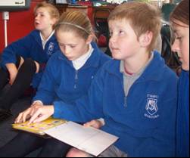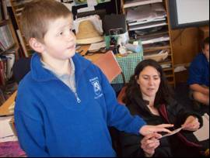

The class had been singing and Tom was very animated. He had been singing loudly and waving his body around. He loves the Homework Blues song. The music finished and the class began their Religious Education work. Tom continued to be very loud and animated. He was waving his arms around. I said to him, “Tom, I think we need to go to the sensory room.” I opened the communication book and pointed to the sensory room visual. I said, “I think we need to go to sensory.” Tom pointed at the sensory room visual which I interpreted as he agreed with us going there. We walked to the Where is Tom? Board and I assisted Tom hand over hand to locate and use the sensory visual.

Tom is learning to use the symbols in his communication book to make choices and to exchange information. He requires help to locate symbols and hand over hand prompts can be given.

Tom Teacher: Annie Date: 25 August 2010
We were in the classroom and I was talking on the phone. I was near the doorway where Tom has a Where is Tom? board. Tom came across to me and located the strip with Motor Skills on it and pointed at the Motor Skills while I was on the phone. I ended the phone call, took his communication book and placed it on the floor next to him. Tom had the Motor Skills visual strip in his hand. He looked at the communication book, but did not open it. I waited. After a couple of minutes I opened the book at the places page. Tom sat on the floor and looked away. He looked down, pointed at the Motor Skills visual on the places page and walked over to me. He held up the Motor Skills visual strip. He pointed at the Motor Skills visual on the communication book. I interpreted this to mean Tom wanted to go to Motor Skills. I said, “Tom, let’s go to the hall.” Tom and I walked over to his teacher, showed her the visuals and she farewelled Tom.
We went to the Where is Tom? board and placed the strip on it. I held the communication book and Tom and I went to the hall for 10 minutes of Motor Skills work.

Another step forward Tom. You are starting to recognise that we can use the same symbols with different resources. We will keep supporting you to recognise lots of symbols in your book, on the board and around school and home.

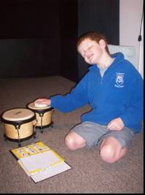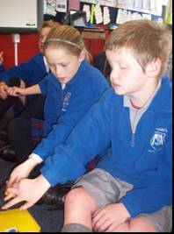

What do Tom’s peers think?

Daniella says:
When we were doing the roll Tom got his communication book and gave it to Sue. Sue opened it to where the teachers are and when Ms Lunevich called his name he looked at her and pointed at her face without Sue helping him. I think he was saying good morning to Miss Lunevich.

Jameson says:
Tom came up to me this morning in the playground court. He pointed to the ball which I had in my hand. I gave it to him and he started throwing the ball in the air. He picked it up and he threw it at me. I picked it up and asked him if he wanted to throw it again. He kept pointing at it so I threw it again. He laughed. I think he enjoyed playing with me.

Amber says:
Last week I was on the playground court and Tom came over to me and took me by the hand. He took me back in to Room 5 to his Where is Tom? board. He pointed to playground so I took him outside on to the playground and then he went over to the monkey bars and he tried to swing on them. I think he was showing me how he swings on the monkey bars. In class he usually takes my hand and he walks to the board to show me what he wants to do.

Jack says:
In the morning our teacher will call out the first name on the roll and say good morning to that person. That person says good morning to the next person on the roll. Tom has to say good morning to me. When we start the roll Tom has the communication book in his hands and Sue has the page open at the kids’ photos. Connor says good morning to Tom, then Sue holds Tom’s hand and they point to my photo and Sue says, “Good morning Jack.”
When I was in the hall with Tom we were using the scooter boards. He hopped on to the board, then after a while he hopped off and he grabbed the rope. He walked over to me and pushed me over to the board and then pushed down on my chest to sit me down. He picked the rope and started pulling me. I think he was maybe wanting to try a new way of playing.

Chrissy says:
We were in the classroom and Tom was on his computer. I said to him, “What are you doing Tom?” He stood up and he picked his communication book on the desk. He opened the book at the food page. He saw it and turned the page then he went to people. He pointed to my picture. He stood up and grabbed my arm and took me to the Where is Tom? board and he pointed to Motor Skills. I think he wanted me to take him to Motor Skills. We went to the hall with Sophie Rose. When we got to the hall Tom went to the stage. He went to the cupboard where the board is and we played with the rope and the board. I think he is communicating much better than he was now that he has his new book. He has more choices about what he wants.

What do Mum and Dad think?
At home Tom is reading his communication book as he eats his meals. Tom has already enjoyed looking at books and he is choosing this book to slowly read and look at while he eats. We think this shows in the ways he can find the pictures and symbols he wants.

What do others think?
Margaret Jackson, Speech language therapist, Special Education, 8 September 2010.
Tom appeared generally happy during the time I observed him. I was very impressed at how much he is engaging and actively communicating with others – through his use of his communication book and ‘Where is Tom?’ board, as well as facial expressions, gestures, noises (I am sure I heard a “No” today!) and movement /physical proximity.
After the maths activity Sue told Tom it was time to make toast for morning tea. Sue got out the communication book and Tom pointed to CD/DVD visual in the ‘About Me’ section. Sue said “No, Tom” and used hand-over-hand to point to toast and jam in the ‘Food/Drink’ section. Tom then went with Sue to the staff room without protest.
Once he had finished his toast, Sue offered him the communication book again and asked him what he wanted to do. He appeared a bit frustrated and flicked through the pages of the book as if he couldn’t find what he was looking for. Sue prompted him verbally to slow down and try again, and he then pointed to the CD/DVD visual again. Sue honoured his request (very important!) and we went to the library and watched a DVD. Tom requested comfort by physically taking Sue’s arm and putting it around him, then protested over the choice of DVD by getting up and picking out the DVD he wanted to watch (Thomas the Tank engine). Sat calmly, smiling while it was playing.
Tom did not appear to want to leave the library when the bell rang (flapped his arms, and made unhappy sounds)….Sue facilitated the transition by engaging him in a playful game where he put his arms around her neck and pulled himself up – lovely eye contact and smiles and laughter from Tom during this exchange.
I asked to see the sensory room, but when we put sensory room visual on the ‘Where is Tom’ board, Tom changed it to ‘Hall” Motor skills’ visual. Tom then went to play on the scooter board with Jack and Connor. Tom obviously loves this activity! I saw his sense of humour when Jack let go of the scooter board and Tom came hurtling towards me….I pretended to cower and Tom laughed his head off before using his legs to stop the board crashing into me! Later, Jack showed Tom “finished” sign and tried to put the board away. Tom verbally protested and snatched the rope from Jack and gave it to Connor – very effective way of communicating “I want more!” Connor pulled Tom around for a few more minutes before prompting “1-more”, then using “finished” sign. Tom appeared content with this and allowed the board to be put away without protest.

Tom’s IEP Meeting, September 2010

Prior to the IEP meeting all members had an opportunity to read the narratives about Tom’s communication efforts. At the meeting we discussed his achievements and identified future learning goals for us all.

What is happening here?
(Analysis of links to curriculum)

Using Language, Symbols and Texts, Participating and Contributing
It is fantastic to see Tom understanding and using language, symbols and text to convey his needs and wants to us through the use of gesture, his board and the communication book. A significant step forward for us is the observation that Tom is now able to ask a question using his book. These narratives also identify Tom as a valued community member who actively participates and contributes to school and home life.

Level 1: English: Speaking, Writing and Presenting: ideas and language
Tom is recognising and using a large bank of high frequency symbols to convey ideas. He is able to combine up to three symbols to convey more than one idea if we give him the time to communicate.

What is Tom teaching us?
Tom is showing us that he has identified two preferred tools to communicate with us, his Where is Tom? chart and his new communication book. He is demonstrating a confidence and belief that we will respond to his communications. We recognise that this brings new challenges for us, but we are excited to observe Tom communicating his needs clearly to us. Tom is demonstrating to us that he can question, recognise, label, argue and identify his needs clearly using the board and book. This is more noticeable with highly desirable activities and we hope to support Tom to generalise this skill to less desirable tasks. We are so surprised that Tom has recognised where symbols are in his book so quickly. We also recognise that the dividers may need some tweaking as we wish Tom to use the book more quickly to convey his communication.

What are Tom’s peers teaching us?
Tom’s peers are teaching us that they value him as a learner, a communicator and a friend. They already understand the importance of symbols for Tom’s communication and they are happy to support him when he initiates communication with them and by initiating the communication themselves. Tom’s peers are teaching us the value of community responsibility for communication through their everyday actions and responses.

Where to next for Tom?
Presently the aide or adult is responsible for most times when Tom accesses the book. We have discussed the long term goal of Tom independently carrying and using his book (or in future possibly a hand held communication device). We will add a strap to Tom’s book in a similar fashion to a PECS folder. We will work on providing a weight bearing activity in the sensory programme as we introduce the idea of Tom carrying his communication device himself.
We need to support Tom to recognise categories. We have made a number of visual resources to support this learning. We have observed him finding the symbols he wants in his book, but have yet to use a divider system we are happy with. The icons at the side are small and we are unsure that Tom is using them. We know he has identified where in the book certain symbols are, but we are not yet sure if he is using the dividers efficiently.
We have identified further symbols required for the book and these will be added to it in term 4. Priorities are WAIT and behaviour symbols.

Where to next for those supporting Tom?
We need to remind each other to provide Tom with as many opportunities as possible to use the communication book. We also need to remind the children at school and who Tom plays with out of school that the book is Tom’s communication tool. We know that there are others (Talklink / SE Speech Language Therapist) who can help us if we get stuck or feel that we are not providing Tom with effective communication strategies. It may be that there are other examples of dividers that we have not accessed. We will activate help from both these sources if we feel we need to.

Next IEP is to be held in Term one, 2011.

